**CHAPTER-8 Class Room Objective**

**COMPLETION OF INCOMPLETE FIGURE**

In this type of problems, a figure or a matrix, containing a set of figures following a particular sequence or pattern is given, in which a part, generally a quarter, is left back. This problem figure is followed by four alternative figures. The candidate required to select the one which best fits into the black space of problem figure so as to complete the original pattern.

**Select the figure from amongst the four alternatives, which when placed in the blank space of fig. (X) would complete the pattern.**

**Ex1.**

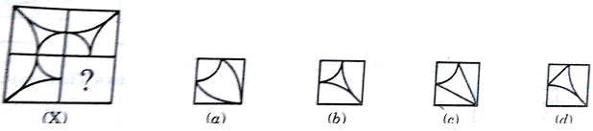

**Ex2.**

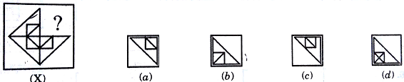

**Ex3.**

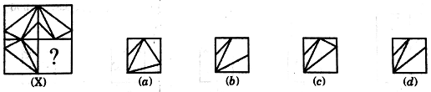

|  |
| --- |
| **EXCERCISE** |

**Q1.**

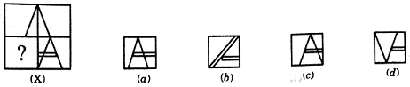

**Q2.**

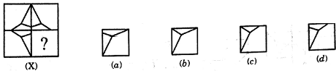

**Q3.**

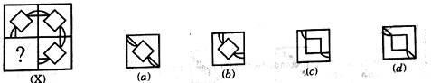

**Q4.**

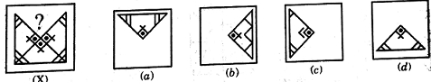

**Q5**.

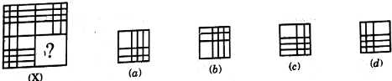

**Q6**.

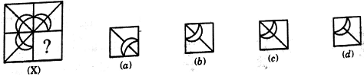

**Q7.**

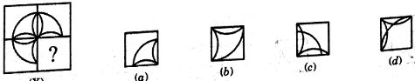

**Q8.**

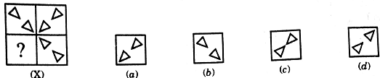

**Q9**.

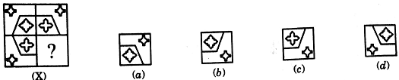

**Q10.**

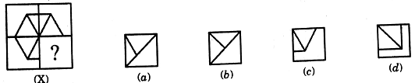

**Q11.**

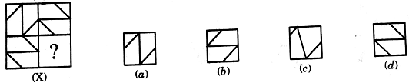

**Q12**.

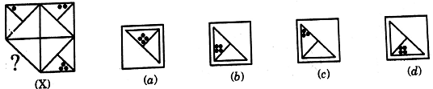

**Q13**.

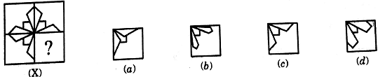

**Q14.**

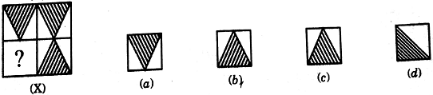

**Q15.**

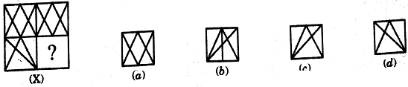

**Q16.**

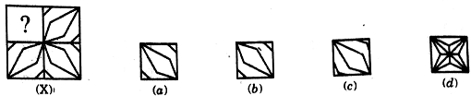

**Q17.**

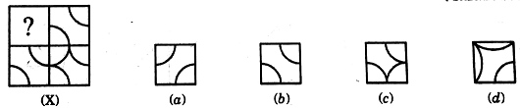

**Q18.**

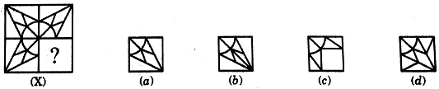

**Q19.**

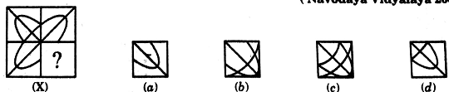

**Q20.**

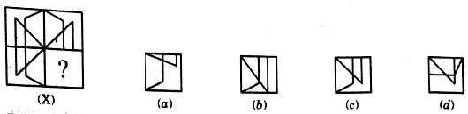

**Q21**.

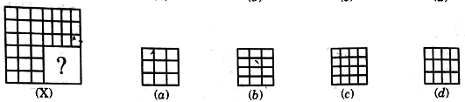

**Q22.**

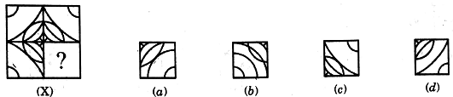

**Q23.**

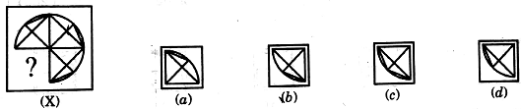

**Q24.**

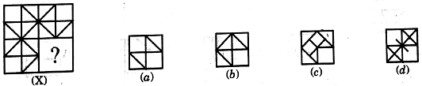

**Q25.**

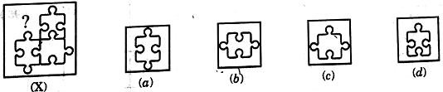

**Q26.**

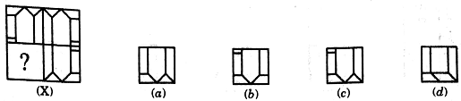

**Q27.**

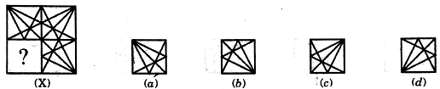

**Q28.**

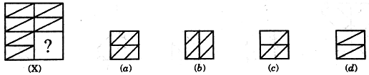

**Q29.**

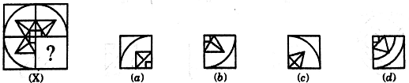

**Q30.**



